1. The 2-Tier Architecture is back way from 90s (I think).
2. In 2-Tier Architecture we have Client and Server.
3. This is Client-Server Architecture.
4. Earlier, we noticed that we have 3 Layers (Presentation Layer, Business Logic Layer, Data Management Layer).
5. We can distribute these three layers in different ways on 2-Tier Architecture.
6. **Distribution of 3 Layers in Two-Tier Architecture**:
   1. **Thin Client**:
      1. When Client Machine has Presentation Layer and Server has other two layers (Business Logic Layer and Data Management Layer),   
         it is called Thin Client.
      2. The burden from the Business Logic Layer is on the Server.
   2. **Thick Client** (also called **Fat Client**)
      1. When Client Machine has Presentation Layer and Business Logic Layer and Server has only Data Management Layer,   
         it is called Thick Client.   
         Mobile App is good example of **Thick Client**.  
         Facebook when installed on mobile is Thick Client but when through browser, we access it, it is Thin Client.
7. 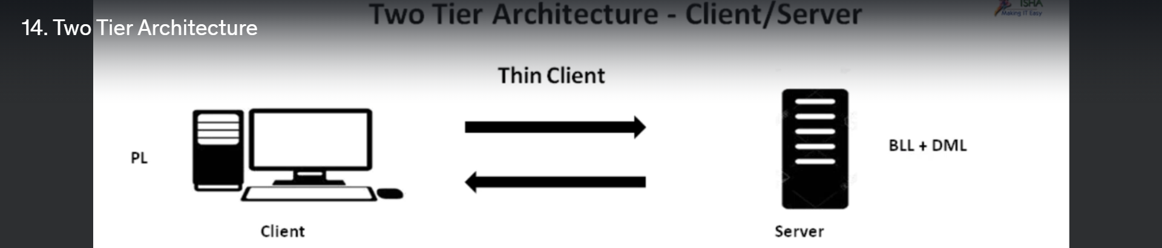  
   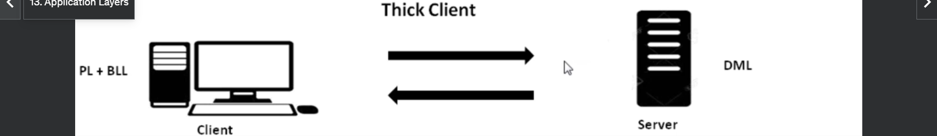Mobile App is good example for Thick Client as Presentation Layer and Business Logic Layer sit on client’s mobile.